RCM Maintenance Setup

Tuesday, August 4, 2020

10:02 AM

|  |  |
| --- | --- |
| **Subject** | **RCM Maintenance Setup** |
| **From** | Brian Dietz |
| **To** | Brian Stockell |
| **Sent** | Thursday, June 25, 2020 3:32 PM |

Here’s what I have:

RCM Cloud Maintenance

Wednesday, May 15, 2019

1:09 PM

RCM Cloud Maintenance (name may change) is designed to perform maintenance functions currently only available in classic. Phase I includes mostly simple code sets from Codes Maintenance. It uses two sites: a front end piece that redirects traffic to the back end site.

**Installation of Sites**

1. Remote into the host server for the sites (STKL-FERRARI)
2. Locate the RCM Web Maintenance folder in the S drive release folder.

Machine generated alternative text:
Home 
Favo rites 
Desktop 
Downloads 
Share 
View 
ThisPC 2019 
Name 
2019.1 
Sea 
RecentPIaces 
OneDrive - Medsphere Systems Corporation 
This pc 
Desktop 
Documents 
Icslntefface 
Insight 
RCM Cloud 
RCM Web Maintenance 
Reporting 
Scripts 
SignalR 
Warehouse 
Date modified 
4/2/2019 AM 
4/2/201gg:16AM 
4/18/2019 10:28 AM 
4/18/2019 1029 AM 
5/13/2019 11:23 AM 
4/15/2019 1:53 PM 
5/15/201gg:17AM 
Type 
File folder 
File folder 
File folder 
File folder 
File folder 
File folder 
File folder 
File folder

1. Open the folder and navigate to the Setup folder.
2. Copy the WebMaint\_BackEnd\_2019xxx and WebMaint\_FrontEnd\_2019xxxx folders.
3. Paste them to the Inetpub > wwwroot folder on the host server (STKL-FERRARI)
4. Create folders called InsightWebMaint\_Back and InsightWebMaint\_Front.

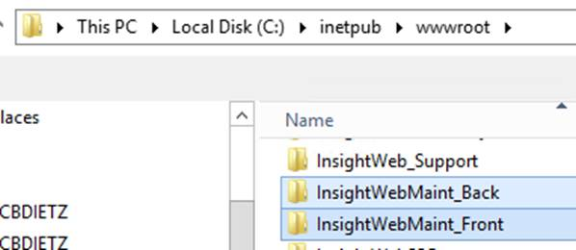

1. Open the zip files and copy them into the corresponding site (front and back) folders.
2. Make the following updates:
   1. Front site folder:
      1. The Web.config file should not need updates.
      2. The "main.xxxxx" file will need to be updated:
         1. Right+click open the main.xxx file in Notepad

Machine generated alternative text:
index 
main.Odgb I g I e86S31315c5cb 
polyfiIIs.3f57b1df632707d6ö44f

1. Do find/replace of localhost for the back end site address. The front end sites redirects traffic to back end, so that's why back end address is used

Machine generated alternative text:
Replace 
Find what 
Replace Al 
Match case

1. Save the file.
2. Back site folder:
   1. Open the Web.config file and set the add origin  to the address of the front end site (<http://stkl-ferrari:4444>)
   2. 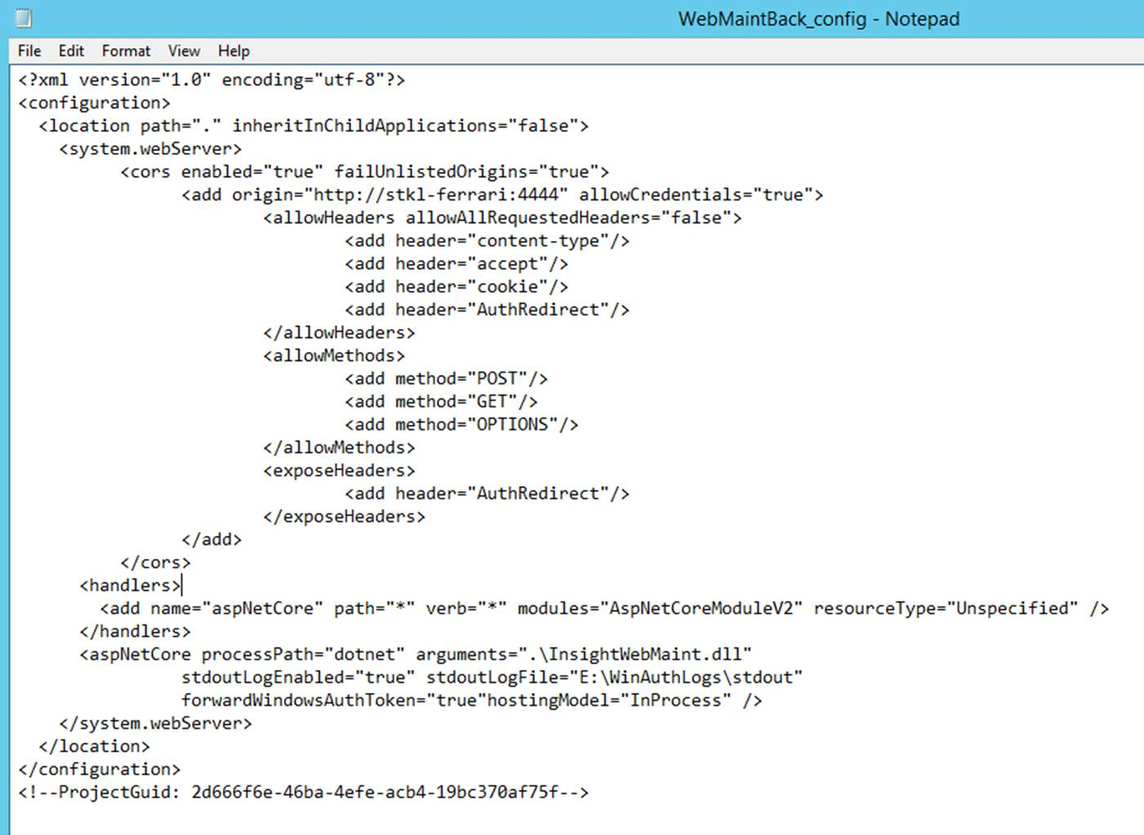
   3. Right+click open the appsettings.json file in Notepad.
   4. 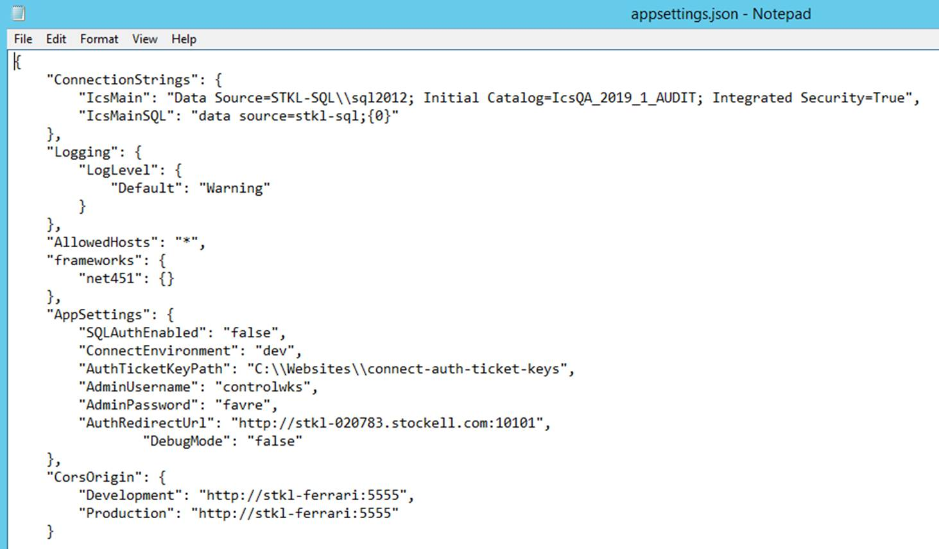
   5. Update the IcsMain data source to the database path.
   6. Update the CorsOrigin path to the back end web site address (<http://stkl-ferrari:555>).
3. Create an application pool for InsightWebMaint\_Back with the following settings:

Machine generated alternative text:
Edit Application Pool 
Name: 
Insi ht',VebMaint Back 
.NET CLR version: 
No Managed Code 
Managed pipeline mode: 
Classic 
e] Start application pool immediately 
Cancel

Machine generated alternative text:
Advanced Settings 
(General) 
.NET CLR Version 
Enable 32-8it Applications 
Managed Pipeline Mode 
Queue Length 
Start Mode 
CPU 
Limit (percent) 
Limit Action 
Limit Interval (minutes) 
Processor Affinity Enabled 
Processor Affinity Mask 
No Managed Code 
False 
g htWebMaint_8ack 
OnDemand 
NoAction 
False 
4294967295 
Processor Affinity Mask (64-bit c 4294967295 
Process Model 
Generate Process Model Event L 
Identity 
Idle Time-out (minutes) 
Idle Time-out Action 
medsphere\mscferrari 
Terminate

1. Create the InsightWebMaint\_Back site with the following settings:

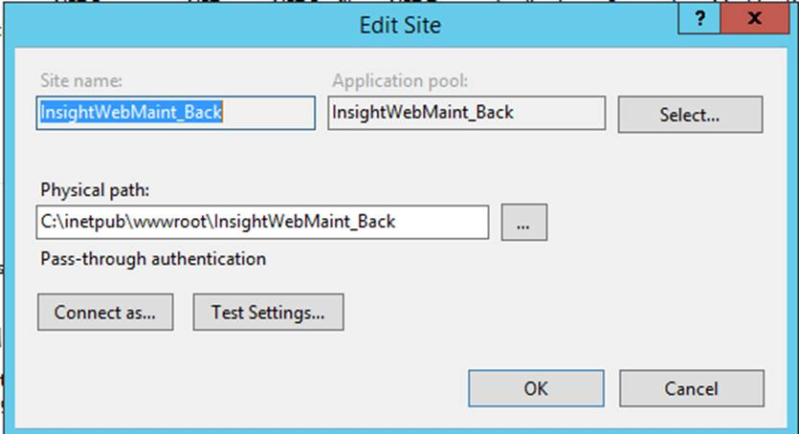

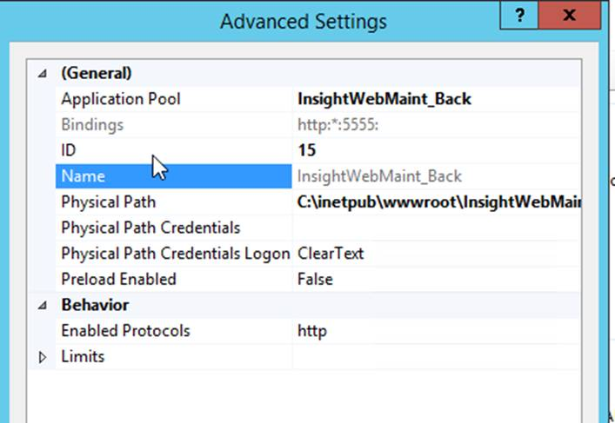

1. Create an application pool for InsightWebMaint\_Front with the following settings:

Machine generated alternative text:
Edit Application Pool 
Name: 
Insi ht',VebMaint Frcnt 
.NET CLR version: 
No Managed Code 
Managed pipeline mode: 
Integrated 
e] Start application pool immediately 
Cancel

Machine generated alternative text:
Advanced Settings 
(General) 
.NET CLR Version 
Enable 32-8it Applications 
Managed Pipeline Mode 
Queue Length 
Start Mode 
CPU 
Limit (percent) 
Limit Action 
Limit Interval (minutes) 
Processor Affinity Enabled 
Processor Affinity Mask 
No Managed Code 
False 
Integrated 
htWebMaint_Front 
OnDemand 
NoAction 
False 
4294967295 
Processor Affinity Mask (64-bit c 4294967295 
Process Model 
Generate Process Model Event L 
Identity 
Idle Time-out (minutes) 
Idle Time-out Action 
medsphere\mscferrari 
Terminate

1. Create the InsightWebMaint\_Front site with the following settings:

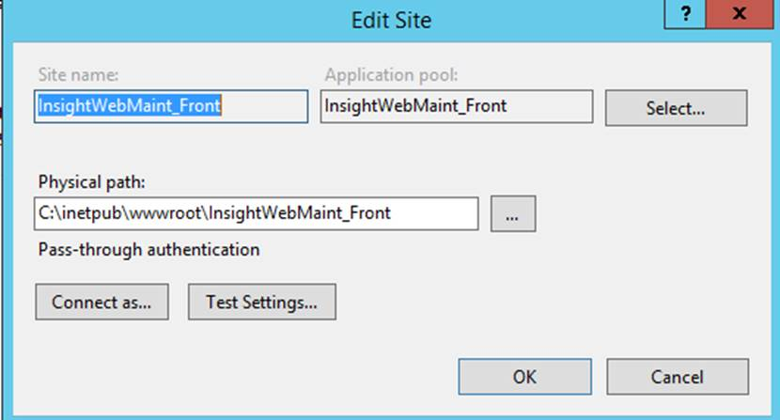

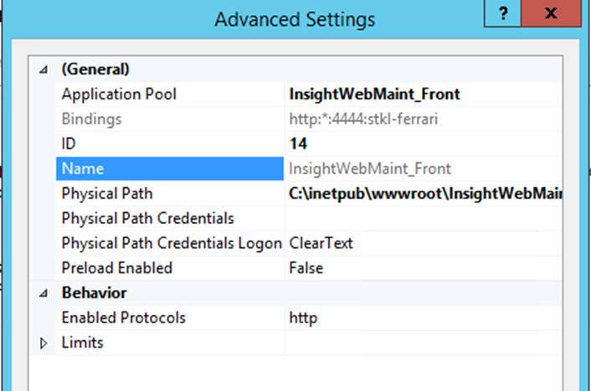

1. Start the application pools.
   1. The order does not matter.
2. Start the sites.

**Updating the Sites**

1. Remote into the host server for the sites (STKL-FERRARI).
2. Locate the RCM Web Maintenance folder in the S drive release folder.
3. Open the folder and navigate to the Setup folder.
4. Copy the WebMaint\_BackEnd\_2019xxx and WebMaint\_FrontEnd\_2019xxxx folders.
5. Paste them to the Inetpub > wwwroot folder on the host server (STKL-FERRARI)
6. In IIS, stop both sites and the application pools
7. Clear the folders except for the Web.config file for front end
8. For back end, clear except for web.config and appsettings.json

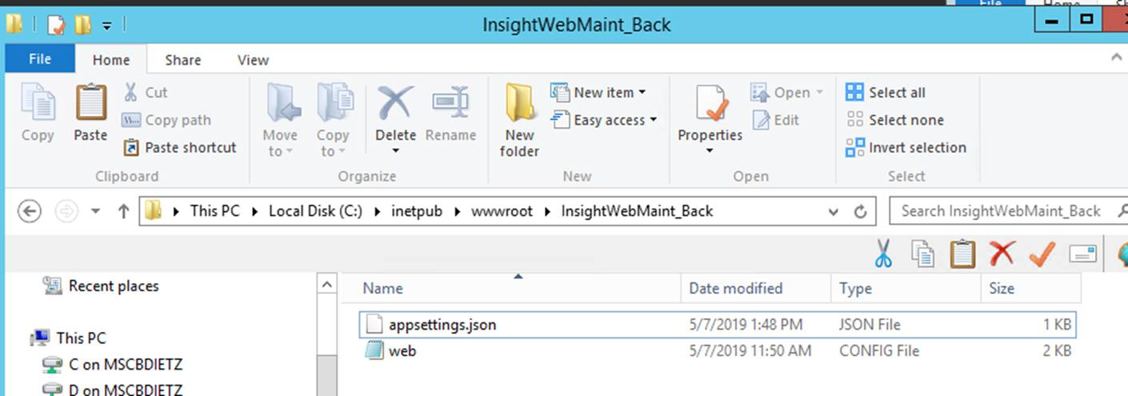

1. Open front end zip file and copy all except the web config.
2. In front end, right+click open the main.xxx file in Notepad

Machine generated alternative text:
index 
main.Odgb I g I e86S31315c5cb 
polyfiIIs.3f57b1df632707d6ö44f

1. Do find/replace of localhost for the back end site address. The front end sites redirects traffic to back end, so that's why back end address is used

Machine generated alternative text:
Replace 
Find what 
Replace Al 
Match case

1. Open back end zip file and copy all except web.config and appsettings.json and paste into back end folder.
2. Start the application pools.
3. Start the sites.

**Brian Dietz**

Sr. Quality Assurance Analyst

636.764.5038 | Direct

[www.medsphere.com](http://www.medsphere.com/)

